Common Versioning Strategies - Query Parameter Versioning

🌐 What is Query Parameter Versioning
# Source: AI Source: Provided by: [Data Path: Persons Table -> ID Column: 1, Name_En Column: Motasem Essam] -> From: [ChatGPT] on [1/19/2026]
Query Parameter Versioning uses a query string parameter to specify the API version in the request URL.
👉 Think of it as telling the server which version to use by adding a parameter at the end of the URL.

🔑 Key Points
# Source: AI Source: Provided by: [Data Path: Persons Table -> ID Column: 1, Name_En Column: Motasem Essam] -> From: [ChatGPT] on [1/19/2026]
- Version specified as a query parameter – e.g., ?version=1
- Flexible – Can be added to any endpoint without changing the path
- Backward compatibility – Old clients continue to call API with version parameter
- Optional – Can default to latest version if parameter is omitted

🧱 Example

Version 1
# Source: AI Source: Provided by: [Data Path: Persons Table -> ID Column: 1, Name_En Column: Motasem Essam] -> From: [ChatGPT] on [1/19/2026]
GET /users/123?version=1
Response:
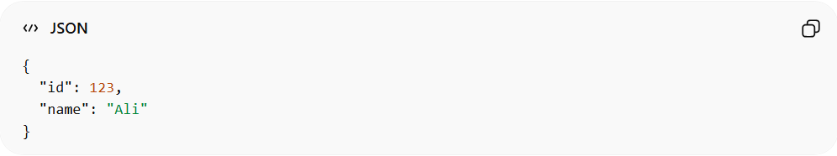
{
"id": 123,
"name": "Ali"
}

Version 2 (added email field)
# Source: AI Source: Provided by: [Data Path: Persons Table -> ID Column: 1, Name_En Column: Motasem Essam] -> From: [ChatGPT] on [1/19/2026]
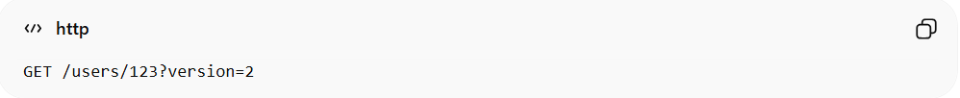
GET /users/123?version=2
Response:
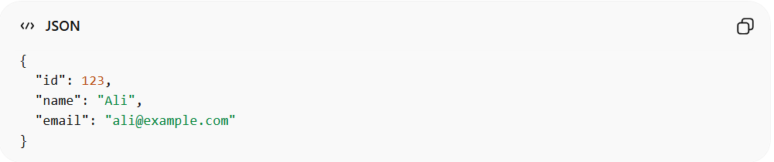
{
"id": 123,
"name": "Ali",
"email": "ali@example.com"
}
✅ Here:
- ?version=1 → old clients
- ?version=2 → new clients

✅ Advantages
# Source: AI Source: Provided by: [Data Path: Persons Table -> ID Column: 1, Name_En Column: Motasem Essam] -> From: [ChatGPT] on [1/19/2026]
- Easy to implement without changing URL structure
- Works well for dynamic version selection
- Can default to latest version when omitted

❌ Disadvantages
# Source: AI Source: Provided by: [Data Path: Persons Table -> ID Column: 1, Name_En Column: Motasem Essam] -> From: [ChatGPT] on [1/19/2026]
- Less visible than URL path versioning
- Might be ignored by caching mechanisms if not handled properly

💡 Summary
# Source: AI Source: Provided by: [Data Path: Persons Table -> ID Column: 1, Name_En Column: Motasem Essam] -> From: [ChatGPT] on [1/19/2026]
Query Parameter Versioning lets clients select an API version by adding a version parameter to the request URL, keeping endpoints flexible and backward-compatible.

